16th Central European NMR Symposium
&
16th Central European Bruker NMR Users Meeting

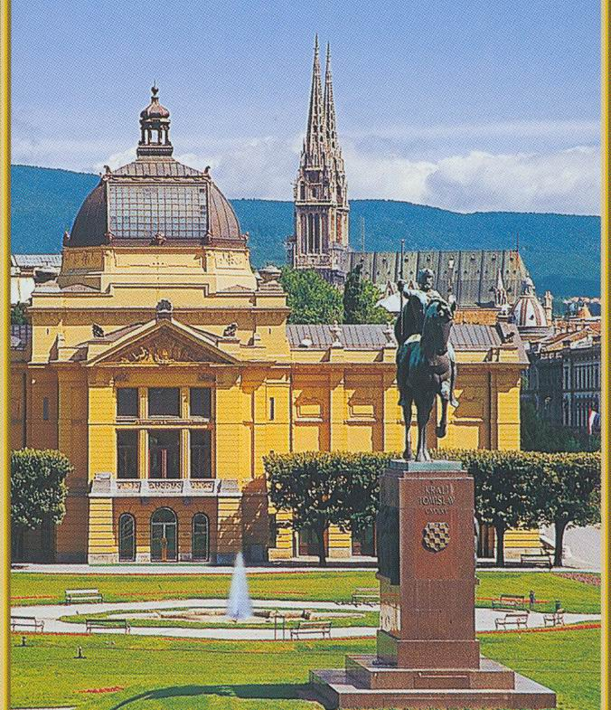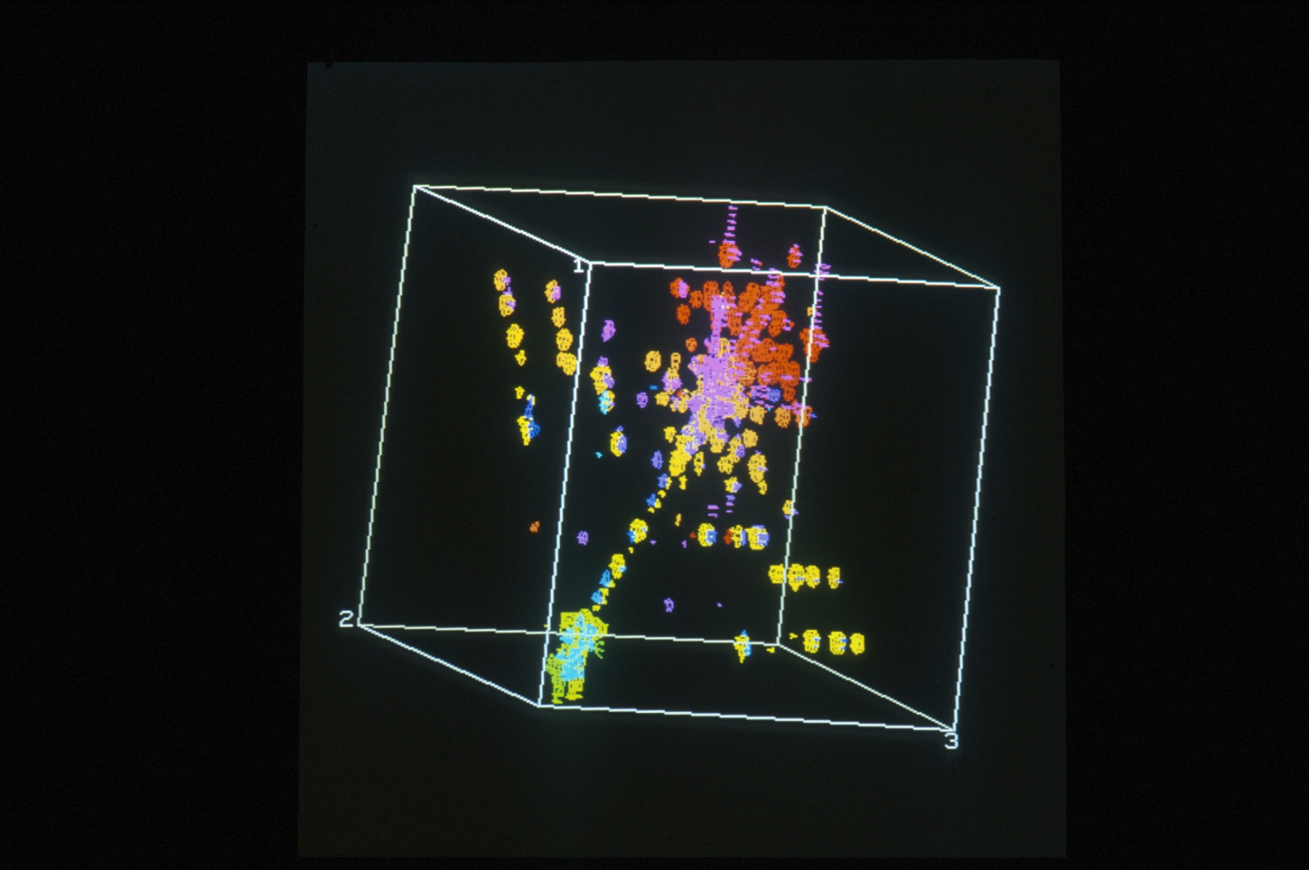

16. - 17. listopada 2014.

INSTITUT RUĐER BOŠKOVIĆ
Centar za NMR

Organizator: Dražen Vikić-Topić

